INTERIM REPORT ON A BRONZE BUCKLE BY RAYMOND WALLWORK 12/03/2022
FOUND ON BUILDING SITE AT BAGINTON 40 YEARYS AGO.
ITS WEIGHT = 2 GRAMS
IT IS 40mm WIDE WITH A HINGED IRON PIN (RUSTED)
IT IS HIGHLY DECORATED ON ALL SIDES. A HORSE IS VISIBLE TO THE NAKED EYE, AS IS AN 8-POINTED STAR, A GOOSE AND A MAN WHEN INSPECTED MORE CLOSELY.

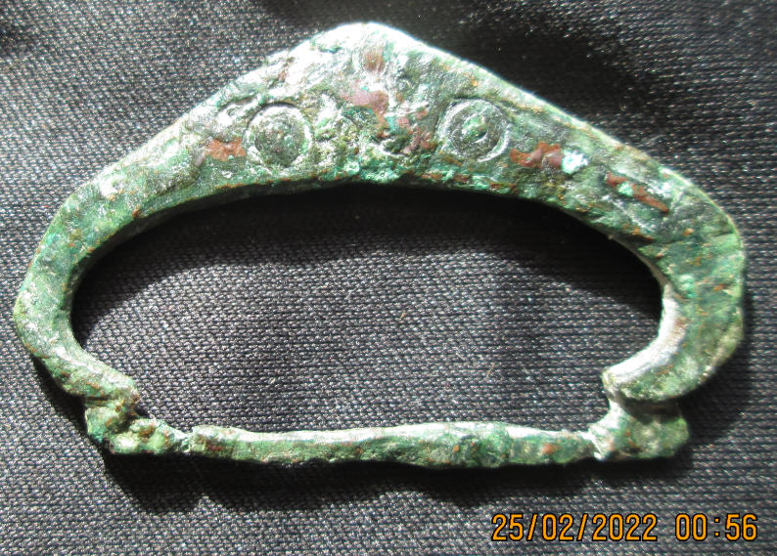
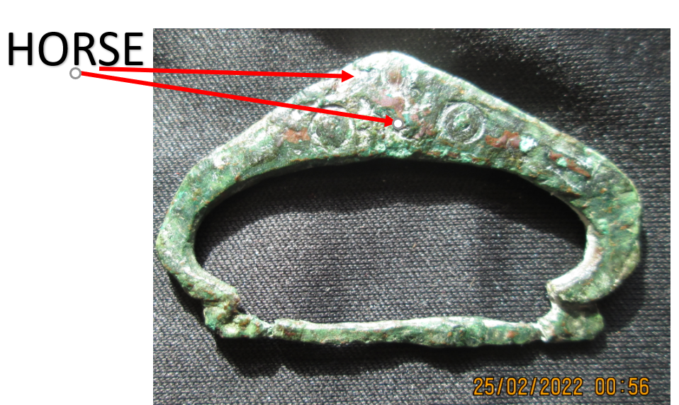

The buckle is rotated 180 degrees in the images below.
